

NATIONAL INSTITUTE OF TECHNOLOGY KARNATAKA

SURATHKAL, MANGALORE - 575 025

Course Code – CS111

Course Name – Computer Programming Lab

Lab - 02

Date – May 11, 2021

Submitted To

Marwa Mohiddin Ma’am

Department of Computer Science and Engineering

National Institute of Technology Karnataka, Surathkal

Submitted By

Md Rakib Hasan

Roll – 201CS132

Department of Computer Science and Engineering

**Question – 1**

The distance between two cities (in km.) is input through the keyboard. Write a program to convert and print this distance in meters, feet, inches and centimeters.

**Answer**

#include<stdio.h>

int main()

{

    float dis_in_km;

    printf("Enter the distance(km): ");

    scanf("%f", &dis_in_km);

    float dis_in_mtr, dis_in_ft, dis_in_inch, dis_in_cm;

    // calculate

    dis_in_mtr = dis_in_km * 1000;

    dis_in_ft = dis_in_km * 3280.84;

    dis_in_inch = dis_in_km * 39370.1;

    dis_in_cm = dis_in_km * 100000;

    // printing

    printf("\nDistance in meters: %.2f\n", dis_in_mtr);

    printf("Distance in feet: %.2f\n", dis_in_ft);

    printf("Distance in inches: %.2f\n", dis_in_inch);

    printf("Distance in centimeters: %.2f\n", dis_in_cm);

    return 0;

}

**Output**

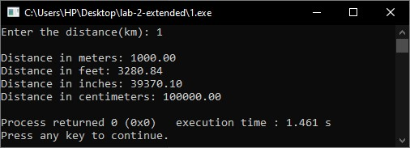

**Question-2**

The length & breadth of a rectangle and radius of a circle are input through the keyboard. Write a program to calculate the area & perimeter of the rectangle, and the area & circumference of the circle.

**Answer**

#include<stdio.h>

#define PI 3.1416

int main()

{

    float length, breadth, radious;

    printf("Enter Length, Breadth & Radious: ");

    scanf("%f %f %f",&length, &breadth, &radious);

    float rect_area, rect_perimeter, circ_area, circ_circum;

    // calculation

    rect_area = length * breadth;

    rect_perimeter = 2*(length+breadth);

    circ_area = PI*radious*radious;

    circ_circum = 2*PI*radious;

    //printing

    printf("\nArea (rectangle): %.2f\n",rect_area);

    printf("Perimeter (rectangle): %.2f\n",rect_perimeter);

    printf("Area (circle): %.2f\n",circ_area);

    printf("Circumference (circle): %.2f\n",circ_circum);

    return 0;

}

**Output**

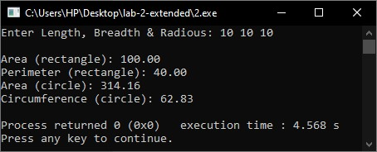

**Question-3**

If a five-digit number is input through the keyboard, write a program to calculate the sum of its digits.

**Answer**

#include<stdio.h>

int main()

{

    int num, sum=0;

    printf("Enter number(five digit): ");

    scanf("%d", &num);

    if((num>9999) && (num<100000))

    {

        // let num = 12345

        int rem = num%10;  // 12345%10 = 5

        sum += rem;        // 0+5 = 5

        rem = (num/10)%10; // (12345/10=1234)%10=4

        sum += rem;        // 5+4 = 9

        rem = (num/100)%10; //(12345/100=123)%10=3

        sum += rem;         // 9+3=12

        rem = (num/1000)%10; // (12345/1000=12)%10=2

        sum += rem;          //12+2 = 14

        rem = (num/10000)%10; //(12345/10000=1)%10=1

        sum += rem;           // 14+1=15

        printf("\nSum of digits: %d\n", sum);

    }

    else

        printf("\nInvalid Input\n");

}

**Output**

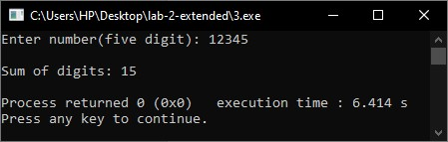

**Question-4**

If a five-digit number is input through the keyboard, write a program to reverse the number.

**Answer**

#include<stdio.h>

int main()

{

    int num, rev_num=0;

    printf("Enter number(five digit): ");

    scanf("%d", &num);

    if((num>9999) && (num<100000))

    {

        // let num = 12345

        int rem = num%10;  // 12345%10 = 5

        rev_num += rem*10000;        // 0+5*10000 = 50000

        rem = (num/10)%10; // (12345/10=1234)%10=4

        rev_num += rem*1000;        // 50000+4*1000 =54000

        rem = (num/100)%10; //(12345/100=123)%10=3

        rev_num += rem*100;         // 54000+3*100=54300

        rem = (num/1000)%10; // (12345/1000=12)%10=2

        rev_num += rem*10;          //54300+2*10 = 54320

        rem = (num/10000)%10; //(12345/10000=1)%10=1

        rev_num += rem*1;           // 54320+1*1=54321

        printf("\nReversed Number: %d\n", rev_num);

    }

    else

        printf("\nInvalid Input\n");

}

**Output**

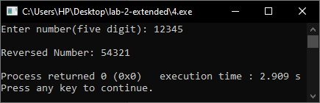

**Question-5**

If the total selling price of 15 items and the total profit earned on them is input through the keyboard, write a program to find the cost price of one item.

**Answer**

#include<stdio.h>

int main()

{

    float total_price, profit;

    printf("Total selling price(15 items) & profit: ");

    scanf("%f %f",&total_price, &profit);

    float actual_cost, per_piece_price;

    //calculation

    actual_cost = total_price - profit;

    per_piece_price = actual_cost/15;

    printf("\nThe cost price of one item: %.2f\n",per_piece_price);

    return 0;

}

**Output**

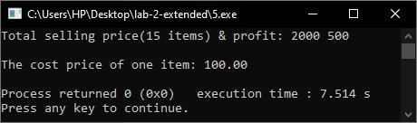

**Question-6**

Write a program to compute the values of square-roots and squares of the numbers 0 to 100 in steps 10

**Answer**

#include<stdio.h>

#include<math.h>

int main()

{

    float n = 0;

    printf("Number = %.0f -> Square = %.2f & Square-root = %.2f\n",n,n*n,sqrt(n));

    n+=10;   // n=10

    printf("Number = %.0f -> Square = %.2f & Square-root = %.2f\n",n,n*n,sqrt(n));

    n+=10;   // n=20

    printf("Number = %.0f -> Square = %.2f & Square-root = %.2f\n",n,n*n,sqrt(n));

    n+=10;   // n=30

    printf("Number = %.0f -> Square = %.2f & Square-root = %.2f\n",n,n*n,sqrt(n));

    n+=10;   // n=40

    printf("Number = %.0f -> Square = %.2f & Square-root = %.2f\n",n,n*n,sqrt(n));

    n+=10;   // n=50

    printf("Number = %.0f -> Square = %.2f & Square-root = %.2f\n",n,n*n,sqrt(n));

    n+=10;   // n=60

    printf("Number = %.0f -> Square = %.2f & Square-root = %.2f\n",n,n*n,sqrt(n));

    n+=10;   // n=70

    printf("Number = %.0f -> Square = %.2f & Square-root = %.2f\n",n,n*n,sqrt(n));

    n+=10;   // n=80

    printf("Number = %.0f -> Square = %.2f & Square-root = %.2f\n",n,n*n,sqrt(n));

    n+=10;   // n=90

    printf("Number = %.0f -> Square = %.2f & Square-root = %.2f\n",n,n*n,sqrt(n));

    n+=10;   // n=100

    printf("Number = %.0f -> Square = %.2f & Square-root = %.2f\n",n,n*n,sqrt(n));

    return 0;

}

**Output**

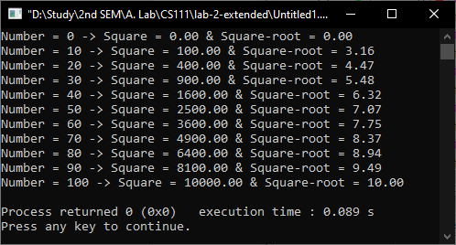

**Question-4** (previous week’s)

Program to accept student roll no, marks in 3 subjects and calculate total, average of marks and print them with appropriate messages

**Answer**

#include<stdio.h>

int main()

{

    int roll;

    float marks1, marks2, marks3, sum, avg;

    printf("Enter roll: ");

    scanf("%d",&roll);

    printf("Enter marks1, marks2 & marks3: ");

    scanf("%f %f %f",&marks1, &marks2, &marks3);

    // calculation

    sum = marks1+marks2+marks3;

    avg = sum/3;

    printf("\nRoll %d:\n",roll);

    printf("Total marks = %.2f\n", sum);

    printf("Average marks = %.2f\n",avg);

    return 0;

}

**Output**

